1. (16pts) Find the derivatives of the following functions. You may use implicit differentiation or logarithmic

differentiation as you feel appropriate. You do not need to simplify your answers.

a. f(x) = sin(x)csc(x) + sin(x)/cos(x)

b.  Note: arcsin is the inverse sine function, i.e., .

$$c. h\left(x\right)= \frac{x^{5}}{(1-20x)\sqrt{x^{2}+2}}$$

$$d. j\left(x\right)={(e^{\sec\left(x\right)}+\ln\left(x\right))}^{2}$$

2.(4pts) The function  is defined as a composition with values . The graphs of 

and are provided below. Given that g(0.25) = 0.06 and f(0.25) = 0.5, determine which of the

values best represents h’(0.25).

1. 0.45
2. 0.9
3. 
4. 
5. -3.2

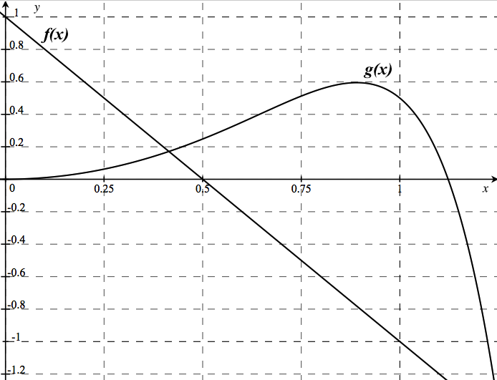

3.(5 pts) Coffee is being poured at a constant rate into the cup shown below. Give a rough graph of the **rate of change**

**of the height** of the coffee in the cup as a function of time and a rough graph of the **height** of the coffee in the cup

as a function of time.

 

 

4. (10pts) Use a tangent line approximation (i.e. linearization) to approximate $\sqrt{16.2}$.

a. (4pts) Write the equation of a line that can be used to find a reasonable approximation of $\sqrt{16.2}$.

b. (2pts) Using your equation in (a), find an approximate value of $\sqrt{16.2}$.

c. (2pts) Sketch a graph of the function and tangent line you used to approximate $\sqrt{16.2}$.

d. (2pts) Based on your sketch, explain whether you think your approximation is an overestimate or an

underestimate.

5. (10pts) Anisha is driving her car 120 miles from San Diego to Los Angeles. She took exactly 2 hours to make

this trip without any stops or detours. Let  be the position in miles of her car at time  hours.

1. Explain why you can apply the Mean Value Theorem to the function  in this problem.
2. Using the mean value theorem, prove that Anisha must have traveled faster than 50mph at some point during her trip.

6. (10 pts) Below is the graph of an implicitly defined function.

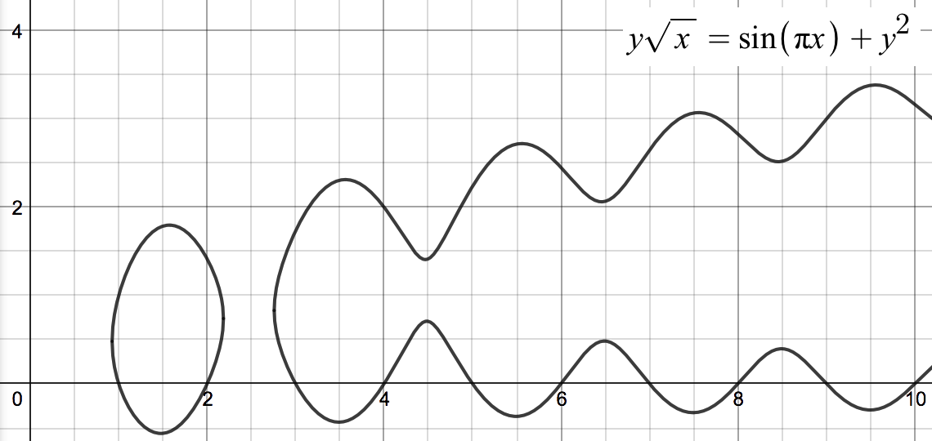

1. (6pts) Use calculus to find dy/dx.
2. (2pts) On the graph above, sketch the line(s) tangent to the graph at x=4.
3. (2pts) Find the equation for one of these lines. (Indicate which tangent line you have chosen.)

7. (5 pts) Find the absolute maximum and absolute minimum values of  on .

8.(20 points) Indicate whether each of the following statements is either true or false. If true, explain how you know. If it is false, explain how you know and provide a counterexample (an example that shows the statement is false).

a (4pts). For any curve defined in the xy-plane, it is possible to solve for a function before taking the derivative (i.e. implicit differentiation is not necessary; it just makes finding dy/dx easier.)

b (4pts). If p(x) is a polynomial, then p(x) attains an absolute minimum and absolute maximum value on [0,5].

c (4pts). If f’(c) = 0, then f has a local minimum or local maximum at x=c.

d (4pts). If f’(x) = 0 for all x and f(0) = 1, then f(x) = 1 for all values of x.

e. (4 pts) Suppose  is a one-to-one differentiable function for all . Suppose that  and

. Then . Hint: Differentiate the equation .

9. (10 points) You’re serving juice to guests at your house. To be festive, you’re storing the juice in a container that is the shape of a cone with the point down. The container is 18 inches deep, and the radius of its circular top is 9 inches. Guests are consuming your juice at a rate of 8. At what rate is the level of liquid in the container changing

when the depth of the juice in your container is 10 in? Show the units. Note:

10. (10 points) A stone is dropped into a pond causing ripples (a disturbance) in the form of concentric circles. The radius of the outer ripple increases at a constant rate of 3 ft/s.

1. (8pts) At what rate is the total area of the disturbed water changing when the radius is 4ft.
2. (2pts) Is the area increasing or decreasing at this time? Use your result in (a) to explain how you know.

Math 150 Exam 2

San Diego State University

Wednesday, November 2, 2016

|  |  |  |
| --- | --- | --- |
| Problem | Points | Points Possible |
| 1 |  | 16 |
| 2 |  | 4 |
| 3 |  | 5 |
| 4 |  | 10 |
| 5 |  | 10 |
| 6 |  | 10 |
| 7 |  | 5 |
| 8 |  | 20 |
| 9 |  | 10 |
| 10 |  | 10 |
| Total |  | 100 |

Name:_________________________________

TA Name: _________________________________ Section:________

**Show** **All** of your work. No work shown = 0 points!

**Box** **All** of your answers, We will not hunt for them.

**READ** the directions, and make sure you answer the question that is asked.

**Please** sign below:

I, the undersigned, hereby pledge that all work on this examination is my own. I have

neither given assistance to any other student, nor received assistance from any other

student. I understand that cheating on this examination will result in a failure as well

as being reported to San Diego State University’s Division of Academic Affairs.

Signature:_________________________________